**Vivekanand Education Society’s** 

**Institute of Technology**

**(Affiliated to University of Mumbai, Approved by AICTE & Recognized by Govt. of Maharashtra)**

**Department of Information Technology**

A.Y. 22-23

MAD & PWA Lab

Journal

| Experiment No. | 09 |
| --- | --- |
| Experiment  Title. | To implement Service worker events like fetch, sync and push for E-commerce PWA |
| Roll No. | 53 |
| Name | SAKSHI SANTOSH PATIL |
| Class | D15B |
| Subject | MAD & PWA Lab |
| Lab Outcome | LO5: Design and Develop a responsive User Interface by applying PWA Design techniques |
| Grade: |  |

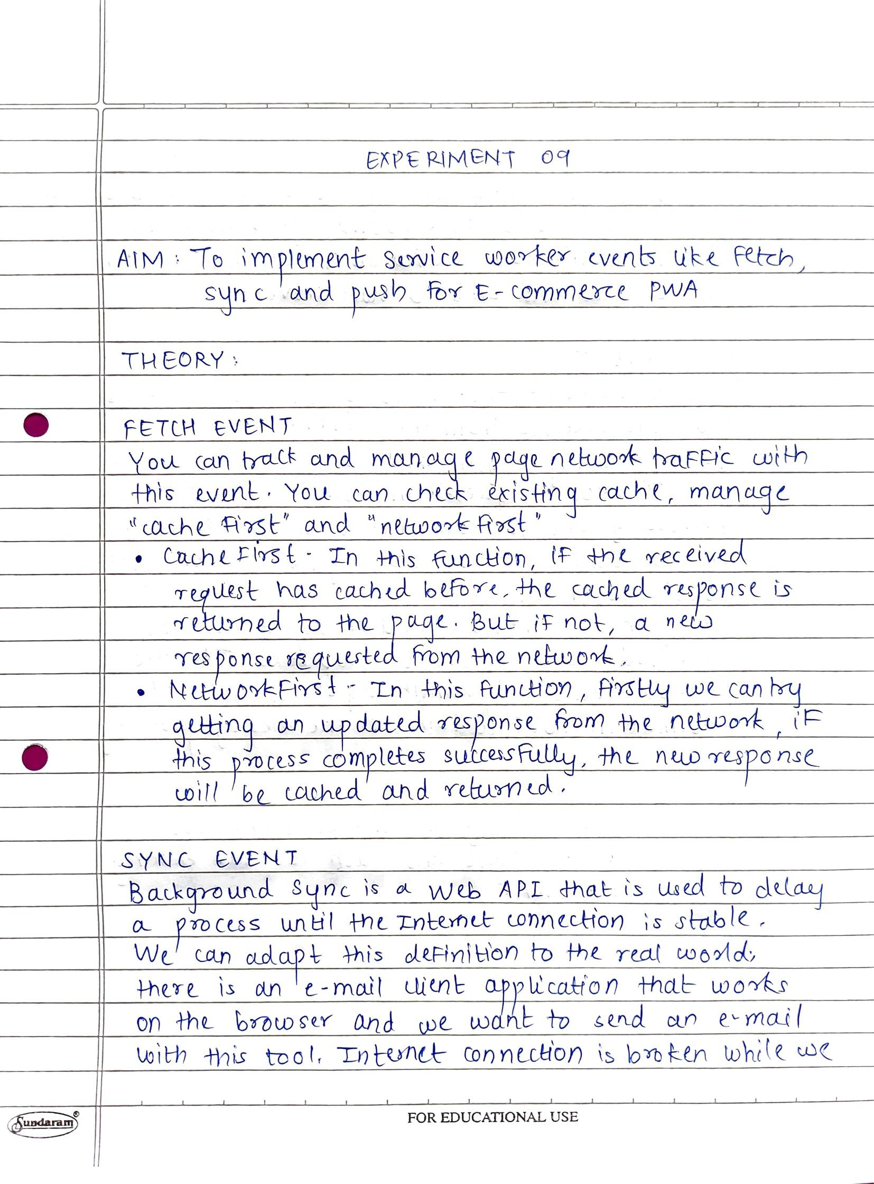

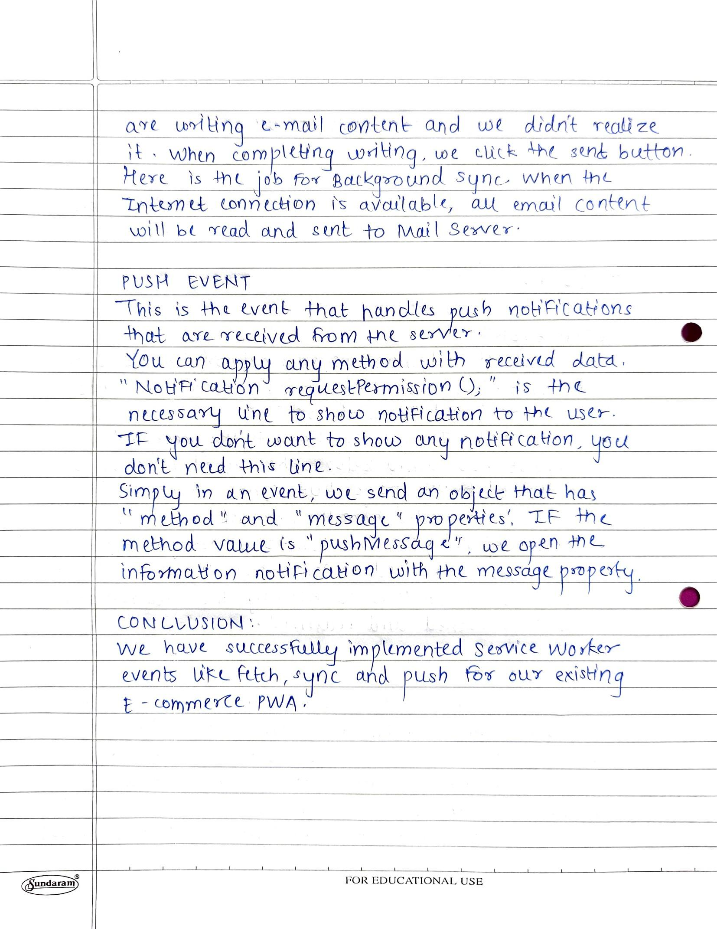

**CODE:**

**serviceWorker.js**

self.addEventListener("install", function (event) {

event.waitUntil(preLoad());

});

self.addEventListener("fetch", function (event) {

event.respondWith(

checkResponse(event.request).catch(function () {

console.log("Fetch from cache successful!");

return returnFromCache(event.request);

})

);

console.log("Fetch successful!");

event.waitUntil(addToCache(event.request));

});

self.addEventListener("sync", function (event) {

if (event.tag === "syncData") {

event.waitUntil(syncData());

}

});

function syncData() {

console.log("Sync event triggered");

}

self.addEventListener("push", function (event) {

console.log("Push received", event);

const payload = event.data ? event.data.text() : "no payload";

const options = {

body: payload,

icon: "/icons/gfg.png",

};

event.waitUntil(

self.registration.showNotification("Push Notification", options)

);

});

var filesToCache = [

"index.html",

"shop-details.html",

"shop-grid.html",

"shoping-cart.html",

];

var preLoad = function () {

return caches.open("offline").then(function (cache) {

// caching index and important routes

return cache.addAll(filesToCache);

});

};

self.addEventListener("fetch", function (event) {

event.respondWith(

checkResponse(event.request).catch(function () {

return returnFromCache(event.request);

})

);

event.waitUntil(addToCache(event.request));

});

var checkResponse = function (request) {

return new Promise(function (fulfill, reject) {

fetch(request).then(function (response) {

if (response.status !== 404) {

fulfill(response);

} else {

reject();

}

}, reject);

});

};

var addToCache = function (request) {

return caches.open("offline").then(function (cache) {

return fetch(request).then(function (response) {

return cache.put(request, response);

});

});

};

var returnFromCache = function (request) {

return caches.open("offline").then(function (cache) {

return cache.match(request).then(function (matching) {

if (!matching || matching.status == 404) {

return cache.match("index.html");

} else {

return matching;

}

});

});

};

**IMPLEMENTATION:**

Cache

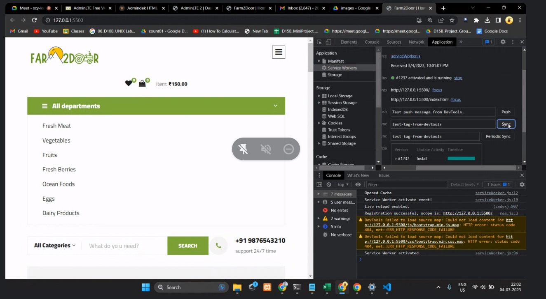

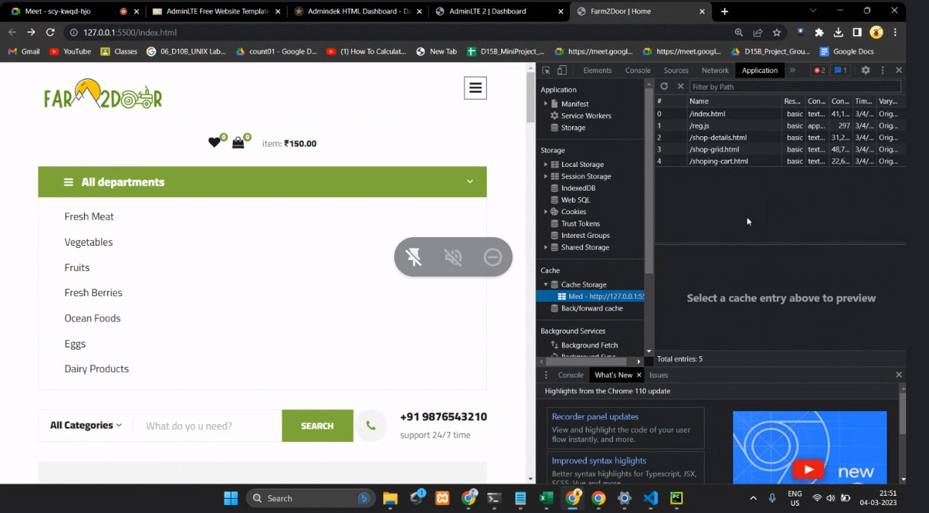

Service worker activated

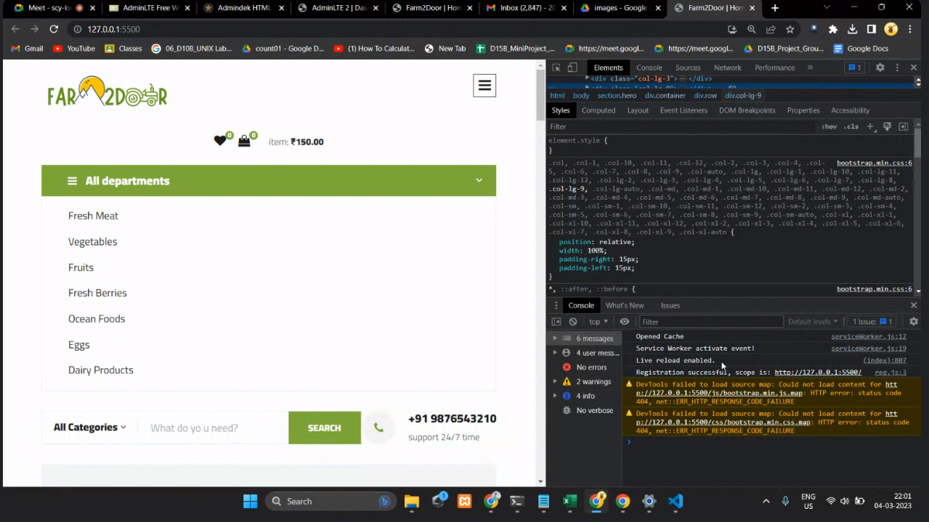

Fetch successful

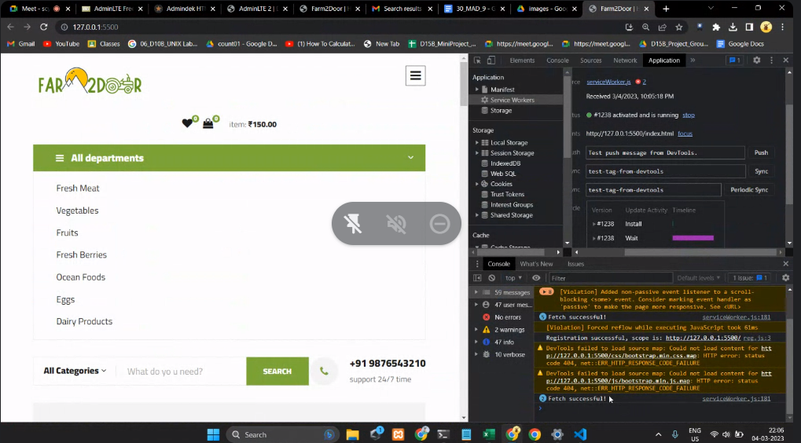

Push received

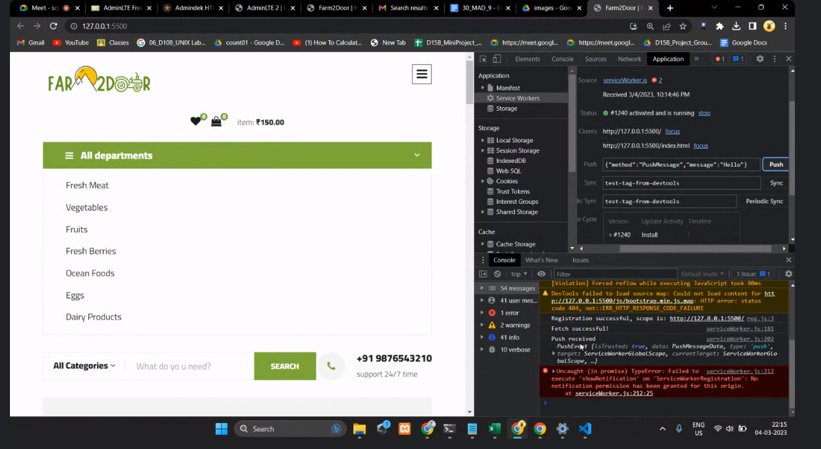

Sync triggered

